Executive Summary
This study investigates how linguistic patterns—negation, contrastive, and conditional expressions—influence the misclassification of neutral (3-star) reviews by a fine-tuned DistilBERT model. Neutral reviews are particularly challenging because they often contain mixed or subtle sentiment signals, resulting in the highest misclassification rates. Our findings show that model errors are not random but are systematically influenced by linguistic structures, with negation significantly increasing misclassification, while contrastive and conditional patterns help reduce errors.

1. Methodology
1.1 Dataset and Prediction
• Used random Amazon review dataset (real-world distribution)
• Selected neutral reviews (label = 1)
• Generated predictions using a fine-tuned DistilBERT model
• Classified each prediction as:
- Correct
- Misclassified
1.2 Linguistic Feature Extraction
Binary indicators were using regex-based pattern detection:
- Negation: not, no, never, none, without, etc.
- Contrastive: but, however, although, yet, still, etc.
- Conditional: if, unless, provided that, assuming, etc.
1.3 Error Analysis Approach
For linguistic pattern:
- Compute misclassification rate:
  - With pattern
  - Without pattern

- Calculate the difference:
Difference = P (pattern | misclassified) – P (pattern | correct)
1.4 Statistical Testing
- Applied Chi-square test of independence
- Hypothesis
  - H₀: Pattern is independent of misclassification
  - H₁: Pattern is associated with misclassification
- Significance level: p < 0.05

2. Results
2.1 Misclassification Rate Comparison use Random Test data
- Negation:
  - With negation: 55.41%
  - Without negation: 45.26%
  - Difference: +10.16%
Notice that: Negation increases misclassification
- Contrastive:
- With conditional: 40.41%
- Without conditional: 47.57%
- Difference: −7.16%Conditional:
Notice tha: Conditional patterns show moderate improvement
2.2 Statistical Findings
A Chi-square test of independence was conducted to examine the relationship between negation and misclassification in neutral reviews. As shown in Table 2.1 (Statistical proof: negation vs misclassification), the observed counts indicate that reviews containing negation have more misclassifications (87) than correct predictions (70), compared to reviews without negation.
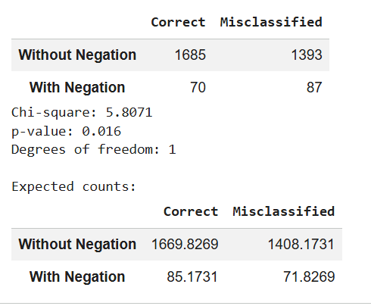
Table 2.1 Statistical proof: negation vs misclassification
The test results (χ² = 5.81, p = 0.016, df = 1) are statistically significant at the 0.05 level, indicating that negation and misclassification are not independent. Furthermore, comparison with the expected counts in Table 2.1 shows that the number of misclassified reviews with negation (87) exceeds the expected value under independence (71.83), while correct predictions are lower than expected (70 vs. 85.17). This provides strong statistical evidence that the presence of negation contributes to increased misclassification in neutral reviews.
Negation Analysis
This analysis examines how individual negation words contribute to misclassification in the 87 neutral reviews identified as errors. The results are summarized in Table 2.1, while Figure 2.1 illustrates the direction of misclassification (predicted negative vs. predicted positive) for each negation word.
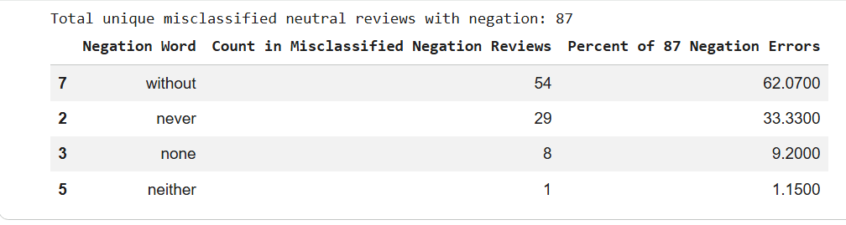
Table 2.2 Word participation counts
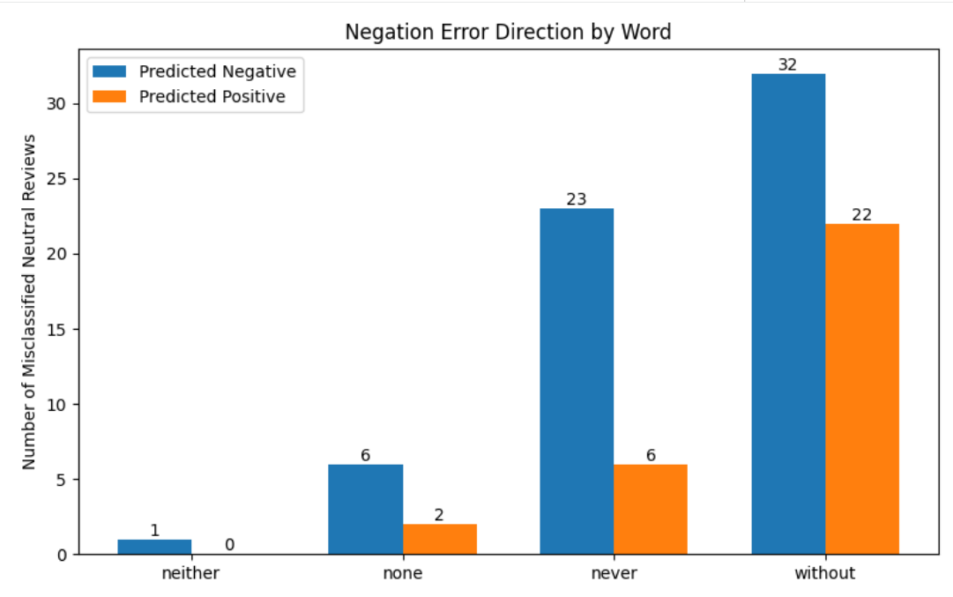
Figure 2.1 Misclassification by negation word
Because a single review may contain multiple negation words, the total word counts can exceed the number of unique misclassified reviews.
- “without” ontributes 62% of errors
- “never” contributes 33% of errors
- Others negation words (e.g., none, neither) have minimal impact
Important observation:
- “without” is often descriptive rather than sentiment-bearing (e.g., “without case”), introducing noise into model’s interpretation.
- “never” reflects true polarity reversal, which directly affects sentiment prediction and more consistently leads to negative classifications (as shown in Figure 2.2)
These results demonstrate that negation is not a uniform linguistic feature. Different types of negation have distinct impacts: some introduce noise, while others directly confuse sentiment interpretation.

3. Key Insights
  - Negation increases errors
- Causes polarity reversal (e.g., “not good”)
- Introduces semantic ambiguity (e.g., “not bad”)
- Includes non-sentiment negation (e.g., “without case”) → adds noise
3.2. Contrastive reduces errors
- Provides clear structure and context
- Helps model interpret mixed sentiment
- Example:
“Good quality but expensive” → clearer signal

  - Conditional shows moderate complexity
- Adds hypothetical or uncertain meaning
- Less harmful than negation
- Still introduces mild ambiguity
4. Conclusion
Linguistic patterns significantly influence DistilBERT’s performance on neutral reviews. Negation increases misclassification, largely due to polarity reversal and its often-ambiguous usage. In contrast, contrastive patterns improve classification performance by providing clearer contextual cues that help the model interpret mixed sentiments. Conditional expressions introduce moderate complexity, reflecting some uncertainty in meaning, but they are less disruptive than negation. Overall, these findings demonstrate that model performance is closely tied to linguistic structure rather than being random. This demonstrates that model errors are systematically linked to language structure, not random.

Report Prepared By: Khine Nwe

